**Experiment 3B**

**Aim:** to study about Cisco Packet Tracer and its IP addresses connection.

**Introduction:** Packet Tracer is a proprietary tool of Cisco. It is used to create & simulate network virtually. It gives same environment virtually as it exists physically. So what you do need to do and work same on all virtually provided devices as you are working with them physically. This is the beauty of this tool. This tool is widely used in CCNA training.

This tool gives all types of network devices require to create one real time working network and also provide same interface as if you are working on a real device.

**Q1. How to set up intruments?**

**A1.** Click on instrument. Then click on page to drop it.

**Q2. How to connect different instruments with cables?**

**A2.** On left bottom corner you will find sign like

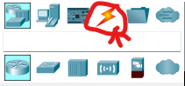

From here you can select your cable.

**Q3. How to set IP Address in any PC/Laptop or Server?**

**A3.** Select PC in which you want to set IP Address, Click on it. One menu will open having three tabs: Physical, Config, Desktop. Select Desktop and go to “IP Configuration”. Here you can set IP Addresses.

**Q4. How to set IP Address in Router?**

**A4.** Select Router, click on it. One menu will open having three tabs:

Physical, Config and CLI.

Select Config. Select Interface in which you want to set IP, i.e.

FastEthernet4.0.

Select IP Address in it & Check the ON check box.

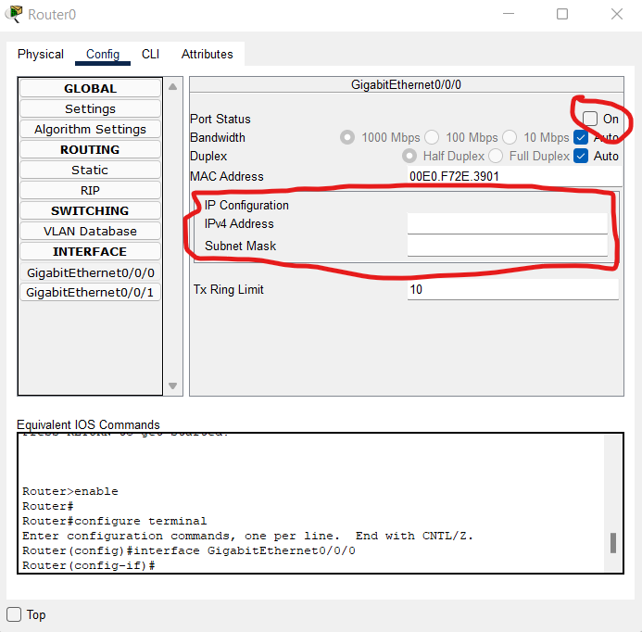

**Q5. What to do is Router doesn’t have enough Ethernet port to connect?**

**A5.** In most of the Routers, it has free physical slots which you can fill up, if you

want to connect more devices with Router.

Select Router,

Select tab Physical,

Now on left side there is list of different kind of Ethernet cards whose

Detail is given in bottom.

Select the one you want.

Now switch off the Router from the right top side on the picture of router.

Now drag the Ethernet card from right bottom most side and drop it on

Routers’ empty slot.

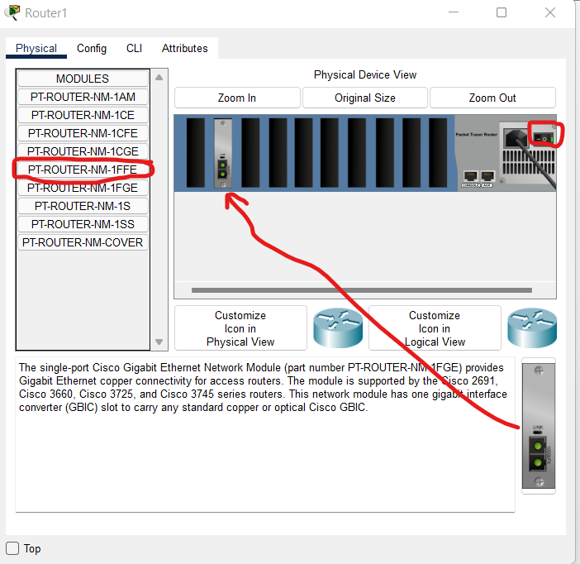

Switch on the Router Again.

**Q6. How to Configure RIP in Router?**

**A6.** In RIP configuration, you just need to enter the network address of all

interface that are directly connected with your Router. In other word, you

need to add all the network addresses which you have entered in different

Ethernet cards in your router.

i.e.

You have Router 1.

You have configured

Fast Ethernet 4/0 with 192.168.0.1/24

Fast Ethernet 5/0 with 192.168.1.1/24

Fast Ethernet 6/0 with 192.168.2.1/24

So for RIP,

You need to enter three network addresses,

192.168.0.0

192.168.1.0

192.168.2.0

